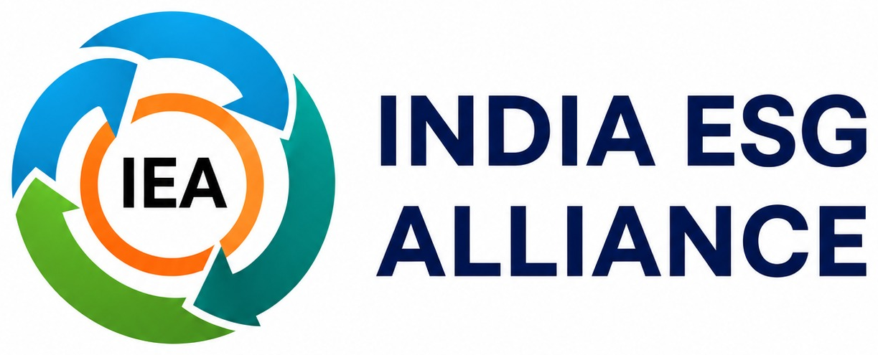
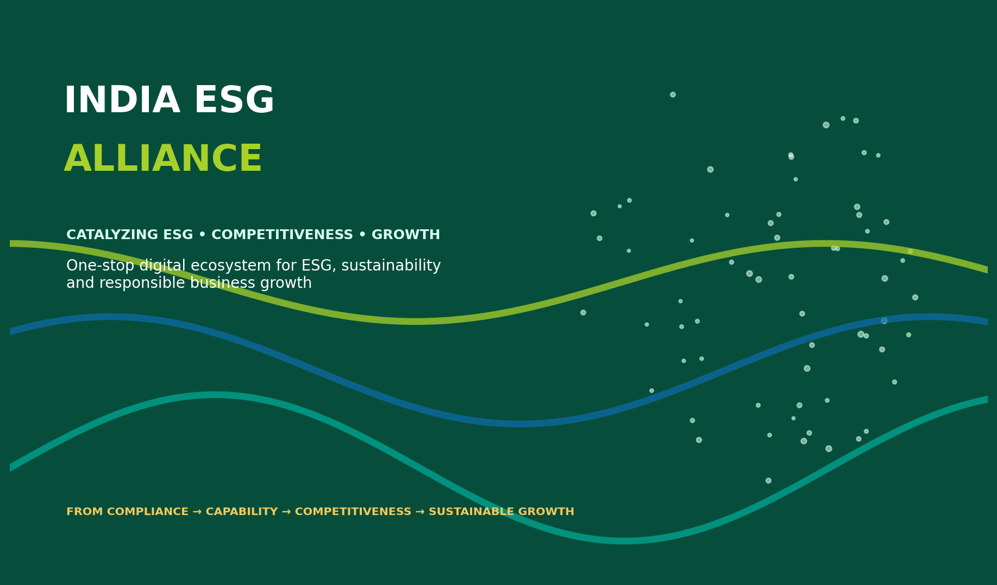
VISION  To build a trusted and inclusive ESG ecosystem that empowers MSMEs and industries to embrace sustainability, strengthen governance and create positive social impact. |  | MISSION  To enable a credible and inclusive ESG ecosystem through knowledge, partnerships and sustainable action.

2025  Established |  | PAN INDIA  Presence |  | 1-STOP  ESG Ecosystem |  | MSME → ENTERPRISE  Focus across scale

OUR PROMISE
Move organisations from fragmented ESG action to an integrated pathway for capability, implementation, measurable performance and sustainable business value.

Why India ESG Alliance?
ESG is shifting from a compliance conversation to a business competitiveness conversation.
The Business Case for ESG

MARKET ACCESS  ESG readiness increasingly influences supplier qualification, export markets and participation in global value chains. |  | BUSINESS PERFORMANCE  Sustainability can improve resource efficiency, resilience, risk management, innovation and revenue opportunities. |  | TRUST & CAPITAL  Credible ESG performance strengthens buyer, investor, lender and stakeholder confidence.

The Gap We Bridge
India already has ESG consultants, technology providers, academic institutions, auditors, financial institutions and development organisations. The challenge is connecting capabilities effectively.
IEA acts as the connective platform — linking business demand with knowledge, expertise, technology, assessment, reporting and implementation support.
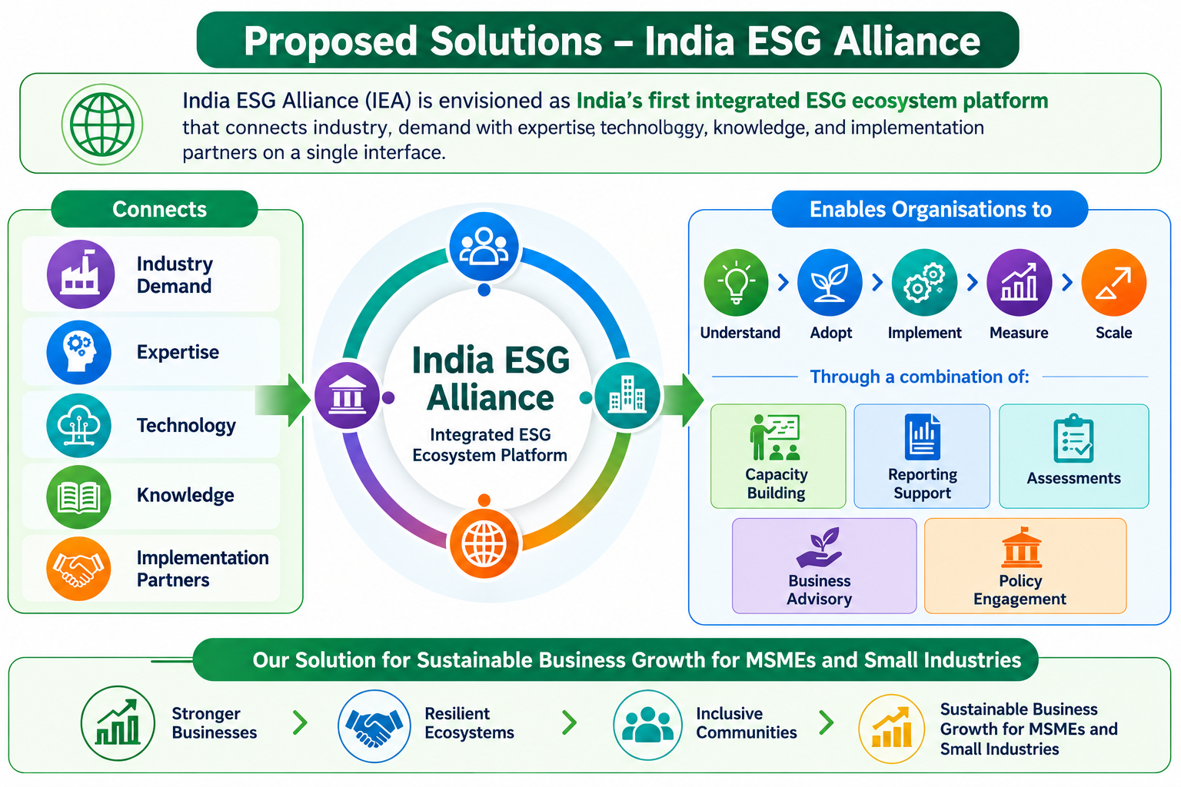

A Continuous ESG Journey

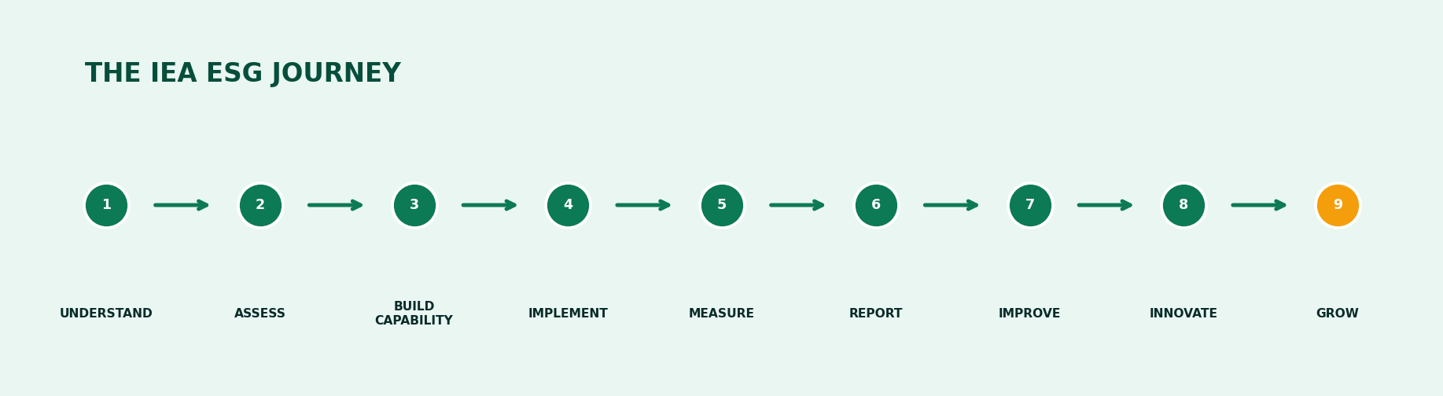
NOT A ONE-TIME REPORT  IEA treats ESG as a continuous process of organisational improvement. |  | FROM QUESTION TO VALUE  Shift the question from “How do we comply?” to “How can ESG help us grow?”

Solutions Built Around Action
Integrated capabilities that help organisations understand, assess, implement, report, improve and grow.
IEA combines capacity building, diagnostics, advisory, technology, reporting, assessment, research, innovation and partnerships through a connected platform.
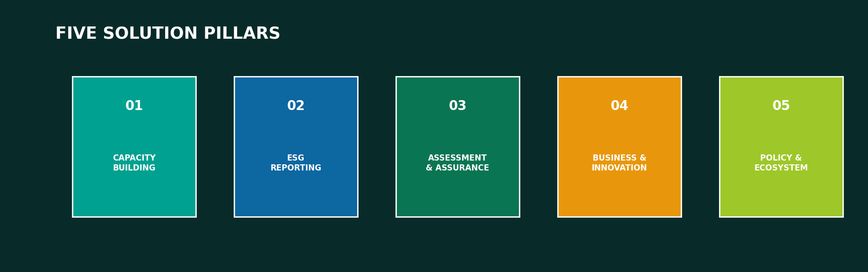

Our Solutions

PILLAR | WHAT IT COVERS | OUTCOMES
01  CAPACITY BUILDING | Board & CXO ESG leadership • Foundational ESG programmes • Sector-specific learning • Workshops • Webinars • Practitioner programmes | Leadership • Skills • Internal capability
02  ESG REPORTING | BRSR & BRSR Core support • Framework alignment • Reporting gap analysis • ESG documentation • Data-system design • Technology-enabled reporting | Data • Disclosure • Reporting readiness
03  ASSESSMENT & ASSURANCE | ESG diagnostics • Maturity assessments • Compliance-readiness • Data verification • Internal audit facilitation | Baseline • Gaps • Improvement priorities
04  BUSINESS & INNOVATION | Expert clinics • Advisory support • Pilot projects • Innovation initiatives • Technology-enabled ESG interventions | Efficiency • Resilience • Market opportunity
05  POLICY & ECOSYSTEM | Government capacity building • MSME transition • Industry engagement • Sustainability programmes • Research • Policy dialogue | Scale • Partnerships • System change

MSME-FIRST DESIGN. Practical, affordable and sector-relevant ESG solutions are designed around MSME realities — linking ESG adoption to operational efficiency, buyer readiness, export competitiveness, risk reduction, stronger governance and access to expertise and technology.
EFFICIENCY  Resource & energy efficiency |  | RESILIENCE  Climate & business resilience |  | BUYER READY  Responsible supply chains

EXPORT READY  Global market expectations |  | GOVERNANCE  Stronger systems & decisions |  | GROWTH  Sustainable business value

BUILD THE ESG ADVANTAGE
A trusted ecosystem for corporates, MSMEs, government, investors, industry, academia, experts and technology providers.

Values Across the Ecosystems

CORPORATES  Strengthen ESG capability, reporting, risk management, sustainability performance and long-term competitiveness. |  | MSMEs  Build ESG readiness, responsible supply-chain participation, market opportunities and sustainable growth. |  | GOVERNMENT & DEVELOPMENT PARTNERS  Use a credible platform for scalable ESG, climate and enterprise-development programmes.

INDUSTRY ASSOCIATIONS  Access sector-specific knowledge, capability building and member engagement solutions. |  | EXPERTS & TECHNOLOGY PROVIDERS  Connect specialised solutions with enterprises seeking ESG capabilities. |  | ACADEMIC & KNOWLEDGE INSTITUTIONS  Create applied research, knowledge partnerships and policy dialogue.

Programmes & Initiatives

01  ESG compliance training for MSMEs |  | 02  Board & CXO ESG Leadership Programmes |  | 03  Two-day business development plan & visioning programmes
04  Sector-specific ESG modules for MSMEs and industries |  | 05  ESG diagnostics and strategy development |  | 06  Design Thinking for revenue and sustainable growth
07  Research, policy advisory, M&E and programme management support to governments |  | 08  MSME exporter programmes and India MSMEs Forum |  | 09  National and state-level ESG summits and one-day ESG foundation trainings

RESEARCH  Applied research • sector studies • stakeholder consultation • policy dialogue |  | CREDIBILITY  Credibility • Expertise • Quality • Independence • Practical impact |  | DIGITAL ECOSYSTEM  Technology provides scale • Experts provide depth • Partnerships provide reach

Ready to Turn ESG into Business Value?
Partner with India ESG Alliance to understand, assess, build capability, implement, measure, report, improve, innovate and grow.
INDIA ESG ALLIANCE (IEA)  One-Stop Digital Ecosystem for ESG, Sustainability & Responsible Business Growth | CONNECT WITH US  indiaesgalliance@gmail.com  Unit No. 8, P3, J Wing, Rustomjee Azziano Road, Majhiwada, Thane West, Maharashtra – 400601, India

ESG WITH BUSINESS GROWTH
SUSTAINABILITY WITH COMPETITIVENESS
RESPONSIBLE BUSINESS WITH LONG-TERM VALUE

